Artificial Intelligence
Project


Session: 2019-CS

Submitted By:
Ali Imran 2019-cs-628
Aqib Naeem 2019-cs-629

Submitted To:
Mam Namra Sheikh

Department of Computer Science
University of Engineering & Technology, Lahore
Question # 1: Naive Bayes
from csv import reader
from math import sqrt
from math import exp
from math import pi
# Load a CSV file
def load_csv():
dataset = []
file = open('iris.data', 'r')
csv_reader = reader(file) # reader returns an iterable object
for row in csv_reader:
if not row: # skips to append if no or empty row is found
continue
dataset.append(row)
return dataset
# Convert the strings into float for calculations.
def str_column_to_float(dataset, column):
for row in dataset:
row[column] = float(row[column]) # each row is selected and column is from 1 to dataset length
# Convert versicolor and setosa etc to numbers like 0,1,2
def str_column_to_int(dataset, column):
class_values = [row[column] for row in dataset] # selecting every single row in dataset
unique = set(class_values) # makes a complete set of rows.
lookup = dict()
for i, value in enumerate(unique):
lookup[value] = i # giving same index(0,1,2) to the strings like setosa and versicolor
print('[%s] => %d' % (value, i))
for row in dataset:
row[column] = lookup[row[column]] # changing the string versicolor and setosa to 0,1,2 in original dataset
return lookup
# Split the dataset by class values, returns a dictionary
def separate_by_class(dataset):
separated = dict()
for i in range(len(dataset)):
vector = dataset[i]
class_value = vector[-1] # picks the last index value from each row
if (class_value not in separated): # if that index is not separated then add it to dictionary as list
separated[class_value] = []
separated[class_value].append(vector) # make a dictionary of rows whose class_value is same (0,1,2)
return separated
# Calculate the mean of list
def mean(numbers):
return sum(numbers) / float(len(numbers))
# Calculate the standard deviation of a list of numbers
def stdev(numbers):
avg = mean(numbers)
# Variance formula
variance = sum([(x - avg) ** 2 for x in numbers]) / float(len(numbers) - 1)
return sqrt(variance) # squareroot of that formula
# Calculate the mean, stdev and count for each column in a dataset
def summarize_dataset(dataset):
summaries = [(mean(column), stdev(column), len(column)) for column in zip(*dataset)]
del (summaries[-1])
return summaries
# Split dataset by class then calculate statistics for each row
def summarize_by_class(dataset):
separated = separate_by_class(dataset)
summaries = dict()
for class_value, rows in separated.items():
summaries[class_value] = summarize_dataset(rows)
return summaries
# Calculate the Gaussian probability distribution function for x
def calculate_probability(x, mean, stdev):
exponent = exp(-((x - mean) ** 2 / (2 * stdev ** 2)))
return (1 / (sqrt(2 * pi) * stdev)) * exponent
# Calculate the probabilities of predicting each class for a given row
def calculate_class_probabilities(summaries, row): #ignore
total_rows = sum([summaries[label][0][2] for label in summaries])
probabilities = dict()
for class_value, class_summaries in summaries.items():
probabilities[class_value] = summaries[class_value][0][2] / float(total_rows)
for i in range(len(class_summaries)):
mean, stdev, _ = class_summaries[i]
probabilities[class_value] *= calculate_probability(row[i], mean, stdev)
return probabilities
# Predict the class for a given row
def predict(summaries, row):
probabilities = calculate_class_probabilities(summaries, row)
best_label = None
best_prob = -1
for class_value, probability in probabilities.items():
if best_label is None or probability > best_prob:
best_prob = probability
best_label = class_value
return best_label
#main function....
dataset = load_csv()
for i in range(len(dataset[0]) - 1):
str_column_to_float(dataset, i)
# convert class column to integers
irisScale = str_column_to_int(dataset, len(dataset[0]) - 1)
# fit model
model = summarize_by_class(dataset)
# define a new record
sampledata =[]
for index in range(0, 4):
value = float(input('Enter data'))
sampledata.append(value)
# predict the label
label = predict(model, sampledata)
for items in irisScale:
if label == irisScale[items]:
print('Its ', items)

OUTPUT:
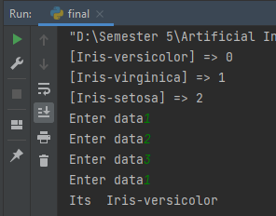

Question #2:
Kmeans
ln [1]:

from sklearn.cluster import KMeans
from sklearn.datasets import load_iris
import pandas as pd
import matplotlib.pyplot as plt
%matplotlib inline

In [2]:

iris=load_iris()

ln [3]:

iris.feature_names

Out[3]:

['sepal length (cm)',
'sepal width (cm)',
'petal length (cm)',
'petal width (cm)']

In [5]:

iris.target_names

Out[5]:

array(['setosa', 'versicolor', 'virginica'], dtype='<U10')

In [6]:

df=pd.DataFrame(iris.data,columns=iris.feature_names)
df.head()

Out[6]:

 | sepal length (cm) | sepal width (cm) | petal length (cm) | petal width (cm)
0 | 5.1 | 3.5 | 1.4 | 0.2
1 | 4.9 | 3.0 | 1.4 | 0.2
2 | 4.7 | 3.2 | 1.3 | 0.2
3 | 4.6 | 3.1 | 1.5 | 0.2
4 | 5.0 | 3.6 | 1.4 | 0.2

In [7]:

df['target']=iris.target
df.head()Y=df.target
newdf=df.drop(['target'],axis='columns')
newdf

Out[7]:
 | sepal length (cm) | sepal width (cm) | petal length (cm) | petal width (cm) | target
0 | 5.1 | 3.5 | 1.4 | 0.2 | 0
1 | 4.9 | 3.0 | 1.4 | 0.2 | 0
2 | 4.7 | 3.2 | 1.3 | 0.2 | 0
3 | 4.6 | 3.1 | 1.5 | 0.2 | 0
4 | 5.0 | 3.6 | 1.4 | 0.2 | 0

In [8]:

Y=df.target
newdf=df.drop(['target'],axis='columns')
newdf

Out[8]:

 | sepal length (cm) | sepal width (cm) | petal length (cm) | petal width (cm)
0 | 5.1 | 3.5 | 1.4 | 0.2
1 | 4.9 | 3.0 | 1.4 | 0.2
2 | 4.7 | 3.2 | 1.3 | 0.2
3 | 4.6 | 3.1 | 1.5 | 0.2
4 | 5.0 | 3.6 | 1.4 | 0.2
... | ... | ... | ... | ...
145 | 6.7 | 3.0 | 5.2 | 2.3
146 | 6.3 | 2.5 | 5.0 | 1.9
147 | 6.5 | 3.0 | 5.2 | 2.0
148 | 6.2 | 3.4 | 5.4 | 2.3
149 | 5.9 | 3.0 | 5.1 | 1.8
150 rows × 4 columns

In [4]:

IMPLIMENTATION OF KMEANS

km=KMeans(n_clusters=3)
# fitness prediction
finalFit=km.fit_predict(newdf[['sepal length (cm)','sepal width (cm)','petal length (cm)','petal width (cm)']])
finalFit
newdf['cluster']=finalFit
newdf.head()
df1=newdf[newdf.cluster==0]
df2=newdf[newdf.cluster==1]
df3=newdf[newdf.cluster==2]
km.cluster_centers_
plt.figure(figsize=(12,7))
plt.scatter(df1[['sepal length (cm)','petal length (cm)']],df1[['sepal width (cm)','petal width (cm)']],color='blue',label='Setosa')
plt.scatter(df2[['sepal length (cm)','petal length (cm)']],df2[['sepal width (cm)','petal width (cm)']],color='r',label='versicolor')
plt.scatter(df3[['sepal length (cm)','petal length (cm)']],df3[['sepal width (cm)','petal width (cm)']],color='green',label='virginica')
plt.scatter(km.cluster_centers_[:,0],km.cluster_centers_[:,1],color='purple',marker='+',s=150,label='centroid')
plt.xlabel('Flower Lenght(cm)')
plt.ylabel('Flower Width(cm)')
plt.legend()
plt.show()
x1=str(input("Enter sepal lenght(cm)"))
print(f"Sepal Lenght: {x1}")
x2=str(input("Enter sepal width(cm)"))
print(f"Sepal width: {x2}")
x3=str(input("Enter petal lenght(cm)"))
print(f"Petal lenght: {x3}")
x4=str(input("Enter petal width(cm)"))
print(f"Petal width: {x4}")

x=[[x1,x2,x3,x4]]
y=int(km.predict(x))

if(y==0):
print("It's a Setosa.")
elif(y==1):
print("It's a Versicolor")
elif(y==2):
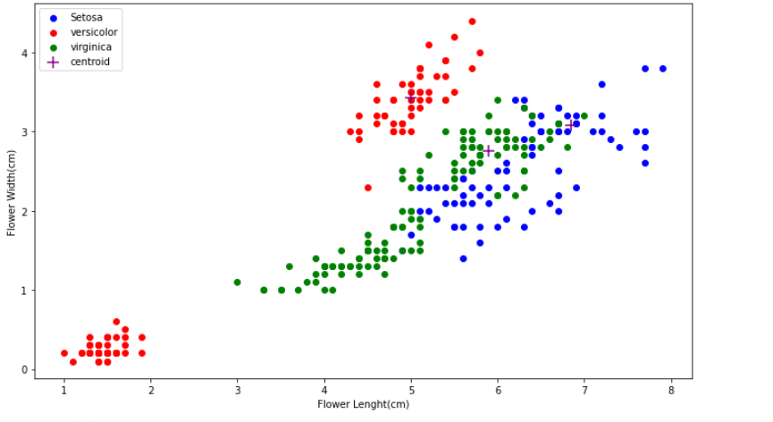
print("It's a Virginica")

Enter sepal lenght(cm)3.4
Sepal Lenght: 3.4
Enter sepal width(cm)2.5
Sepal width: 2.5
Enter petal lenght(cm)1.2
Petal lenght: 1.2
Enter petal width(cm)6.6
Petal width: 6.6
It's a Virginica
In [ ]:

